Hello MNS Families,

**MNS Fall Family Fun Night:**  October 13, 2016 (6:30pm-8:30pm) Please join us with your family for the Amazing Space Race and Astronomy Night!

Arrive for 6:30pm so that students can assemble teams of 2-4 for the "race". The race runs 6:30-7:30pm.  At 7:30, the SJ Astronomy Club will be onsite with telescopes to show us the stars!

The Home and School are looking for about 10 parent volunteers to assist with running the Amazing Space Race stations.  If you are planning to attend and can help out, please email us at [millidgevillenorthHS@gmail.com](mailto:millidgevillenorthHS@gmail.com).

**Java Moose Coffee Fundraiser for Home and School** October 3-11 –We have partnered with Java Moose for our fall fundraiser, to help fund our programs this year.  We all know someone who likes coffee!!

For $10, we will be offering 226g bags of ground or beans, we all as bags of 12 K-Cups.

Flavours include:  Foghorn, Decaf, Bay of Fundy, Cookies and Cream, Cocoa Mochanut, Vanilla Buttercream, Butterrum Fudge, Eggnog and Candy Cane!

Fundraiser sheets will go home with your students today, due back on Tuesday, October 11th.  Payment methods are cash or cheque (payable to Millidgeville North Home and School).



**Breakfast Club and Snack Boxes**

The Breakfast Club and the snack box programs are both up and running at MNS.  As educators we realize the importance of what having a good breakfast and nutritious snacks can do for a child’s capacity to learn for the day. Any child can attend the program or grab an item from the snack boxes located in each classroom. Sometimes we get up late and are too rushed, other times we forgot to eat breakfast or the milk and bread ran out the night before. Whatever the reason, any child at MNS is welcome to use these programs. A special thanks to Mrs. Kingston for all of her help in ensuring a successful start to these programs this year.  Also these programs would not be possible without the financial support from Buick Drive for Kids and Breakfast for Learning.  If you know of a company or organization that would be interested in making either in-kind or financial donations to our breakfast or snack box programs please contact Mme. Price at 658-5353 or [michelle.price@nbed.nb.ca](mailto:michelle.price@nbed.nb.ca).

Registration is now open for the ***Understanding Anxiety & Panic Disorder*** program which begins on Tuesday, October 18th.  Available seats are limited. Pre-registration is required by calling 633-1705.  For more information on the programs provided by CMHA of NB in Saint John, please visit the website <http://cmhanb.ca/category/programs-and-services/saint-john-programs/>.  **Programs offered by CMHA of NB in Saint John are generously sponsored by MindCare New**

**Brunswick**.

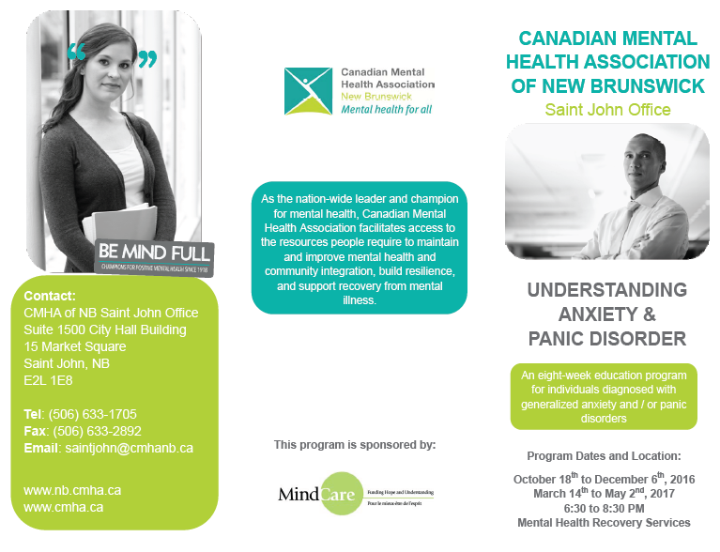

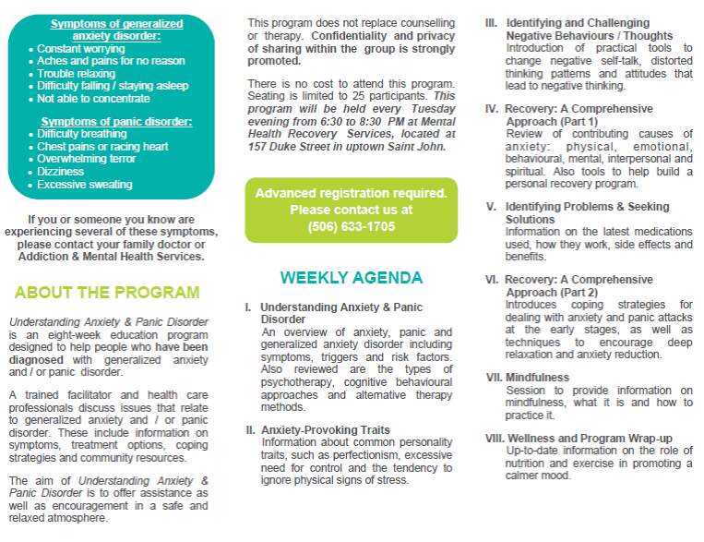

Reminder: **Babysitting Course at MNS** is scheduled for Thursday, October 6, 9:00 am – 3:30 pm, Room A102.

**High Five Friday** is brought to you each and every Friday, rain or shine, by your BTH facilitators. Thanks for your initiative and positive outlook.

**District Education Council Information session at MNS**

Re: Multi Year Infrastructure Planning Process

**Wednesday, Oct 19th 6:30 – 8:30 Cafeteria**

The District Education Council for the Anglophone South School District has launched a long term, multi-year infrastructure planning process to ensure students have access to safe and healthy learning environments.

There are currently seven schools in Saint John’s inner city (K-8), serving a total student population of 1,750. Since 2001, that number has declined by 27%.

Schools in the inner city include:

* four K-8 schools (St. John the Baptist/King Edward, Hazen-White/St. Francis, Princess Elizabeth, Prince Charles)
* one K-2 school (M. Gerald Teed Memorial)
* one K-5 school (Centennial), and
* one 3-8 school (Millidgeville North)

The average age of the seven buildings is 58 years old.

As outlined in the Department of Education and Early Childhood Development’s Policy 409, the District Education Council is mandated to submit a long range, multi-year infrastructure plan for the district, including facility status reviews, school sustainability studies and major capital priority projects.

To begin that process, a study of Saint John inner city schools (kindergarten to grade eight) was prepared by Ernst & Young. It recommends one new school (grades 6 to 8) be built, as well as several grade reconfigurations that will optimize district-owned facilities and vacate leased facilities.

The full report is available on our website at <http://web1.nbed.nb.ca/sites/asd-s/Pages/welcome.aspx>.

The District Education Council will host a series of school community meetings this fall to discuss Ernst & Young’s recommendations, options and to outline the process. Meetings will be held from **6:30 – 8:30 pm according to the following schedule:**

* ***Wednesday, October 19 – Millidgeville North School***
* Wednesday, October 26 – Princess Elizabeth School
* Thursday, October 27 – Prince Charles School
* Tuesday, November 1 – M. Gerald Teed Memorial School
* Wednesday, November 2 – St. John the Baptist/King Edward School
* Monday, November 7 – Centennial School
* Monday, November 14 – Hazen-White/St. Francis School

Each meeting will be followed up with a second meeting approximately four to five weeks later to offer you a chance to ask questions and provide feedback.

In the meantime, you are invited to review the full Ernst & Young report and consider their long term recommendations in the context of your community.

**2016 MNS Raffle Fundraiser**

We will once again be conducting our annual $1000 giveaway fundraiser. This is a major fundraiser for our school and helps to support field trips, sports fees, jerseys, star scholarships, wellness activities and nutrition, among other things. Information and tickets will be going home with students On Monday October 17th and the draw will take place on Friday October 28th.

**Grade 8 Ottawa trip**

Permission slips for the grade 8 trip to Ottawa went home last week.  The permission form along with a non-refundable $100 deposit is due back to Mme. Price by October 21st.   This deadline is important as it helps us to accurately determine the price for the trip.  Deposits received after this deadline may be placed on a waitlist.  If you have any questions please contact Mme. Price at 658-5353 or [michelle.price@nbed.nb.ca](mailto:michelle.price@nbed.nb.ca).

**Terry Fox** – we had a great walk last week to celebrate Terry Fox and raise funds for his foundation and cancer research.  It is a wonderful way for our students to learn about such an inspirational Canadian and about the importance of giving back.  Thank-you to all for your donations and to those parents who volunteered as crossing guards. Please remember to send in pledge sheets this week if you haven't already done so.

**School Pictures**:  Picture day took place on September 28th with staff from Life Touch.  The proofs will be sent back to the school and returned home with students later in October.  This year, families will have the option to order pictures online with many background options to suit your needs.  A date for picture re-takes will be set when the proofs return in the coming weeks.

**No School Dates** – a reminder that there is no school next week on Thurs, Oct. 6th and 7th due to professional learning days for school staff.  Also, there is no school on Mon, Oct. 10th (Thanksgiving).

**Elementary Cross Country** Final Cross Country Event Oct. 5th – 3:45pm at Simm’s Corner

**Scent Free and Nut Free School**

Several of our students have allergies to different types of nuts. Please refrain from sending nuts or products made from nuts so that our students can enjoy a healthy and safe atmosphere.

No scents make good sense. Many of the perfumes, deodorants and body sprays have chemicals that affect the breathing of students and staff. It is a school policy that we must insist on the use of unscented or very lightly scented products.

Thank you for keeping the entire school community in mind when coming to school. ☺

**SCHOOL CAFETERIA**

The online cafeteria ordering system seems to be running smoothly over the past couple weeks. Improvements have been made with the addition of warm containers for food delivery, student helpers and the menu options have increased as well this year. Please visit [www.schoollunchorder.ca/](http://www.schoollunchorder.ca/) to place orders online.

**Immunization Clinic (All Grade 7 Students**

Public health is holding an immunization clinic at the school for Grade 7 students on Friday Oct 28. All grade 7 students will be offered a booster vaccine that protects against Tetanus, Diphtheria, and Whooping cough if they have not received one in the last 5 years. The girls will also be offered a vaccine that protects against cervical cancer. This vaccine is a series of 2 which will be given throughout the school year.

**UPCOMING DATES**:

-Oct 6th baby Sitting Course

- Bus Safety, Tuesday, Oct 11th

-Professional Learning Days Oct 6th and 7th No Classes

-Thanksgiving Monday, Oct 10th (No Classes

-Java Moose Fundraiser Oct 3-11

-MNS Fall Family Fun Night Oct 13th 6:30-8:30

-Oct 19th 6:30-8:30 District Education Council Presentation at MNS

-Grade 7 Vaccinations Oct 28

The MNS Website can be found <https://secure1.nbed.nb.ca/sites/district8/schools/emns/Pages/default.aspx> and our school twitter account can be found @MNSStars

As always, please feel free to contact Mr. Whelton for further information at 658-5353 or by e-mail [Michael.whelton@nbed.nb.ca](mailto:Michael.whelton@nbed.nb.ca)

**School Mission Statement**

The mission of MNS, a diverse family of learners, is to develop independent and confident community members. By promoting kindness.

**School Vision Statement**

MNS’s vision is to:

STRIVE for high expectations & academic excellence

TEACH the whole child

APPRECIATE and celebrate diversity

RESPECT needs, interests and abilities

SHARE within our community